**create table Pokémon:**

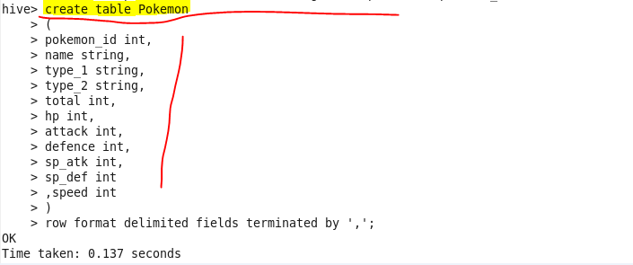

**Load pokemon.txt dataset to Pokémon table:**

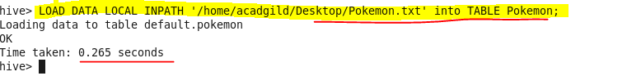

**Find out the average HP (Hit points) of all the Pokémon’s:**

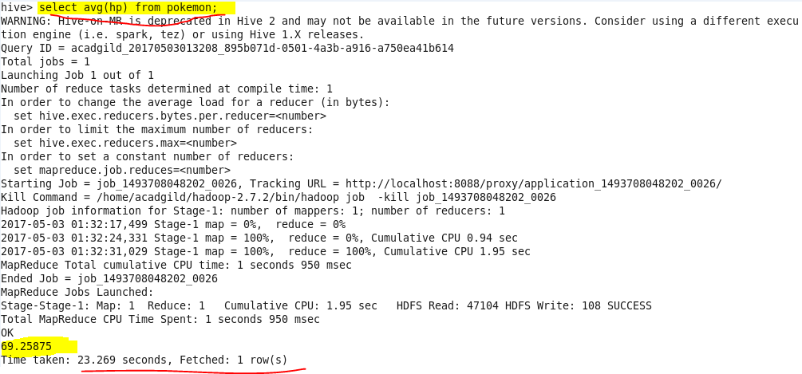

**Find out the average Defense of all the Pokémon:**

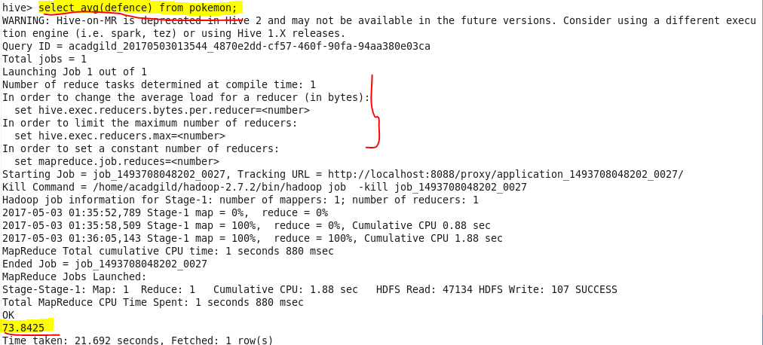

**Find out the average Sp.Atk of all the Pokémon’s:**

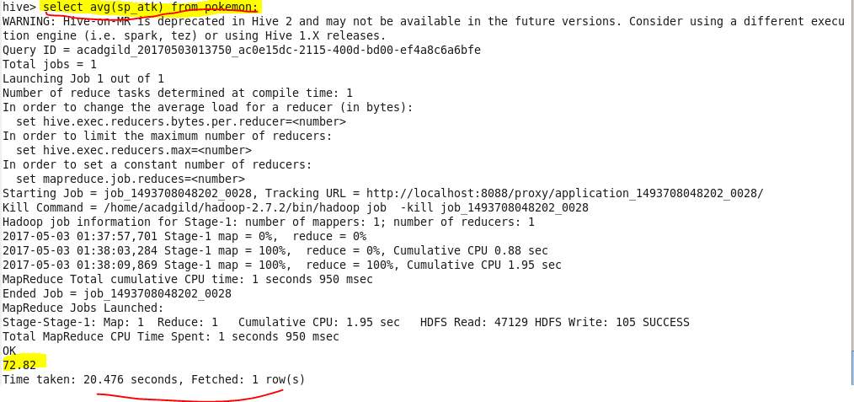

**Find out the average sp.Def of all the Pokémon’s:**

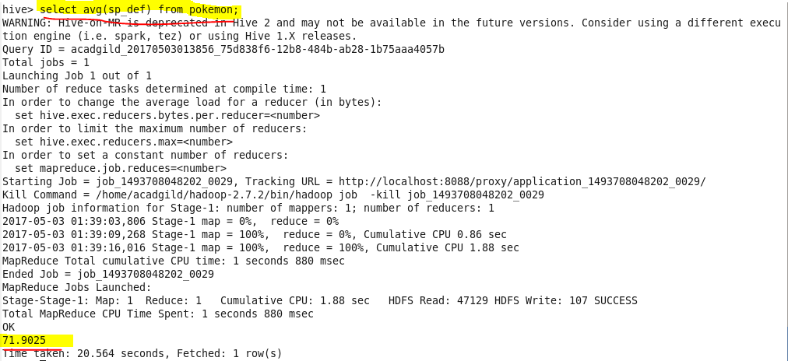

**Find out the average Speed of all the Pokémon’s:**

